DATABASE MANAGEMENT SYSTEMS MINI PROJECT

**TITLE:** LIBRARY MANAGEMENT SYSTEM

# TEAM MEMBERS:

T.GnanaAjaykumar –RA1911003010895

N.Chidvilas – RA1911003010910 A.Chidvilas Reddy – RA1911003010898

# SCREENSHOTS OF DBMS:

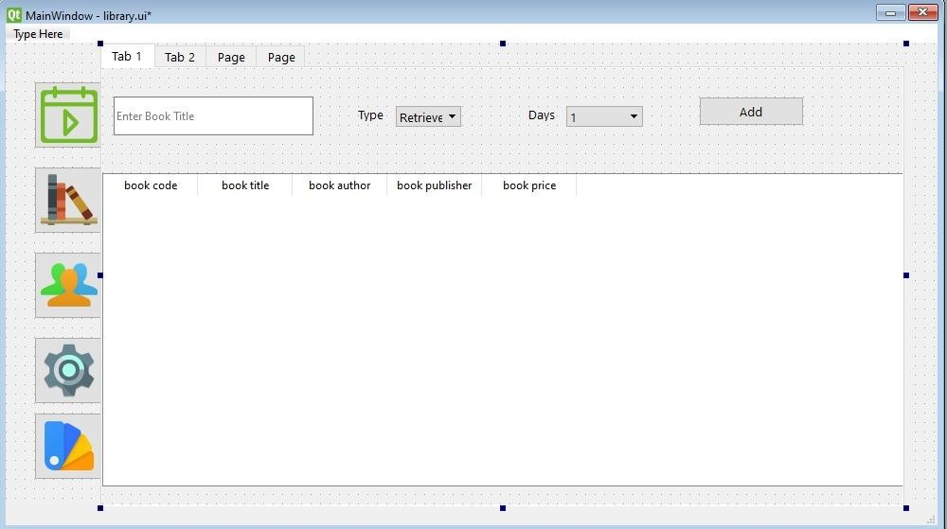

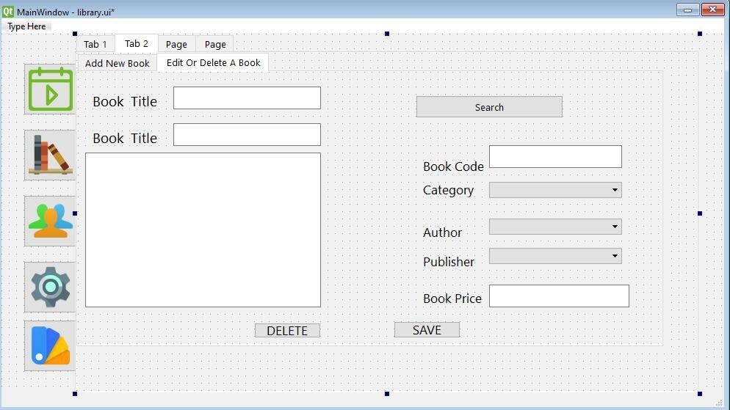

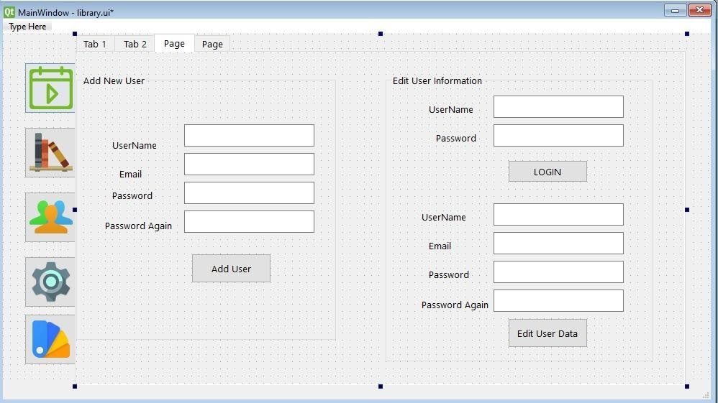

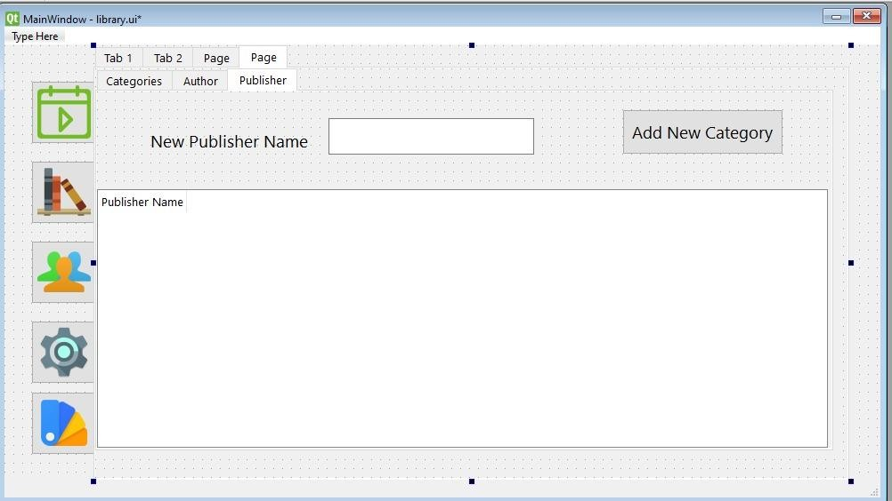

**MODULES:**

A module is a collection of source files and build settings that allow you to divide your project into discrete units of functionality. Your project can have one or many modules, and one module may use another module as a dependency.

There are 6 different modules in this library management system and each module has its own task and speciality to do and save the data and maintain it so that it can be accessed.

They are:

1. Book
2. Users
3. Day_to_day
4. Category
5. Publisher
6. Author
7. Book consists of :
   * title
   * code
   * desc
   * category
   * price
   * author
   * publisher
8. Users consists of:
   * username
   * password
   * email address
9. Day_to_day consists of:
   * book name
   * retrieve / rent
   * days
10. Category consists of:
    * name
11. Publisher consists of:
    * name
12. Author consists of:
    * name